

**2023**



**Care Group**

|  |  |  |
| --- | --- | --- |
| Supervisor | Sir Asif Ahmed Khan | |
| Batch | **PR2-202209C** | |
| Group | **A** | |
| Serial No. | **Enrollment Number** | **Student’s Name** |
| 1. | Student1445457 | MUHAMMAD TAHA KHAN |
| 2. | Student1441785 | USAMA |
| 3. | Student1445028 | SAIF ALI |
| 4. | Student1446587 | MUHAMMAD SAAD MUSTAFA |

# **Table of Content**

­­

* **Table of Contents**.……………………………….…….……………..**.01**
* **Certificate of Completion**……….………………………….….……....**02**
* **Acknowledgement**………………………………………….……...….**03**
* **Problem Statement**….………………………………...……....…..…..**04**
* **Customer Specification**.……………………………………...…….…**04-05**
* **Hardware and Software Requirement**…………..……….…….….……..**05**

* **Project Synopsis**…………..…………………………..…….….……..**06**
* **Website Features** …………..…………………………..…….…..…...**06-07**
* **Checklist of Validation** …………..……………………....…….…..…..**07**
* **Submission Checklist**………….....……………………....…….…..…..**08**
* **Database Design**………….....……………………….......…….…..…..**09**
* **Home Page**………….....……………………....…………….…..…...**10**
* **Admin Dashboard**………….....……………………....……….…..…..**11**
* **Developer Guide**………….....……………………..……….….…..…..**12-13**
* **Flow Chart**………….....……………………..……………..….…..…..**14**
* **Task Sheet**………….....……………………..……………..….…..…..**15**

# **Certificate of Completion**

This is to certify that  **M. Taha, Usama, Saif Ali, & M. Saad Mustafa** have successfully completed their ACCP Prime 2.0

Semester II E-Project.

Submitted to: **Aptech Computer Education**

On

**December 25th, 2023**

# **Acknowledgement**

First of all we would like to thank **Almighty Allah** for giving us strength and ability to complete this project.

And then, we would like to express my special thanks of gratitude to our teacher **Sir Asif Ahmed khan** who guided us on the project**Care Group**, which also helped us in doing a lot of new learning and we came to know about so many new things we are really thankful to him.

We are highly thankful to **Sir Asif Ahmed khan** for his guidance and constant supervision as well as for his support in completing the project.

Lastly, we would also like to thank our parents and friends who helped us a lot in finalizing this project within the limited time frame. We also express our sincere gratitude to I-Project team from Aptech Head Office, for their valuable guidance and support for the completion of this project. We earnestly hope that this project will provide all the necessary information required by the user to fulfill his/her inspiration. However, suggestion and Feedbacks for improvements will be thankfully welcomed & acknowledged*.*

# **Problems Statement:**

We all need to visit doctors some time or the other. Sometimes it is an emergency situation, whereas most of the other time it is a planned checkup/visit. But in both the cases we have to visit the doctor to take an appointment or wait in long queues.

**CARE Group** is into medical services for long time and looking at the current medical scene have decided to come up with a WEBSITE, which will host the medical services available in different cities.

Individuals will be able to search for specialist doctors in their surroundings and even book online appointments.

Web site should also record the complete information regarding the Doctors and Patients.

# **Customer Specifications:**

# **The Web site is to be created based on the following requirements.**

The website will have three users/roles:

* Administrator
* Doctor
* Patient

The Administrator should be able to do the following:

* Add Cities to the master database.
* Add Doctors to the Master database.
* Modify Doctor Details.
* Modify Patient Details.
* Delete Cities.
* Delete Doctors.
* Delete Patients.
* Create/Manage Users/Logins.
* Manage information/details on the WEBSITE.

The Doctor should be able to do the following:

* Login into the system with his USER/PASSWORD.
* View his/her profile.
* Add details to his/her profile.
* Modify his/her profile.
* View Appointments.
* Update his availability for DAY/WEEK/MONTH.

The Patient should be able to do the following:

* Register/Create Account [USERID should be unique].
* Search Doctor based on location, Specialist.
* Book Appointment [Check Availability.

# **Hardware and Software Requirements**

**Hardware**

* A minimum computer system that will help you access all the tools in the courses is a Pentium 166 or better
* 128 Megabytes of RAM or better

**Operating System**

* LINUX / Windows 2000 Server (or higher if possible)

**Software**

* PHP
* MySQL
* PERL
* Apache

# **Project Synopsis**

The Online Medical Services Portal, initiated by CARE Group, is designed to simplify healthcare processes. The platform facilitates easy access to specialist doctors, online appointment bookings, and provides valuable information on diseases, preventions, and cures. With distinct roles for administrators, doctors, and patients, the portal aims to enhance the overall healthcare experience.

# **Website Features**

**Key Features:**

* **Administrator:** Manages cities, doctors, patients, and website information.
* **Doctor:** Accesses and updates personal and professional details, manages appointments, and sets availability.
* **Patient:** Registers, searches for doctors, books appointments, and accesses health-related information.

**Technologies:**

The portal will utilize PHP, MySQL, HTML5, CSS3, and JavaScript for development, ensuring a secure and responsive user experience.

**Implementation:**

Iterative development will be employed, with regular testing and updates. The system will be hosted securely, emphasizing data privacy and integrity.

**Conclusion:**

The Online Medical Services Portal reflects CARE Group's commitment to innovation in healthcare. By providing a user-friendly and efficient platform, the portal aims to improve healthcare accessibility and contribute to community well-being.

# **Checklist of Validation**

|  |  |
| --- | --- |
| **Options** | **Validated** |
| Do all numeric variables have a default value of zero? | YES |
| Does the administer have all the rights to create and delete record? | YES |
| Are all the record properly fed into the appropriate database? | YES |
| Have all the modules been properly integrated are completely functional? | YES |
| Have all the Design and coding Standards been followed and implemented? | YES |
| Is the GUI design consistent all over? | YES |
| Is the navigation sequence correct through all the forms/screens in the application? | YES |
| Is exception handling mechanism implemented in all the screens? | YES |
| Are all the program codes working? | YES |

# **Submission Checklist**

|  |  |  |  |  |  |
| --- | --- | --- | --- | --- | --- |
| **S.NO** | **Particulars** | **YES** | **NO** | **NA** | **COMMENTS** |
| 1 | Are all users able to search for a particular record? | YES |  |  |  |
| 2 | Are all old records properly saved and retrieved when required? | YES |  |  |  |
| 3 | Have all modular been properly integrated and are completely functional? | YES |  |  |  |
| 4 | Are GUI contents devoid of spelling mistake? | YES |  |  |  |
| 5 | Is the application user-friendly? | YES |  |  |  |
| 6 | Is the project published properly into the setup file? | YES |  |  |  |

# **Database Design**

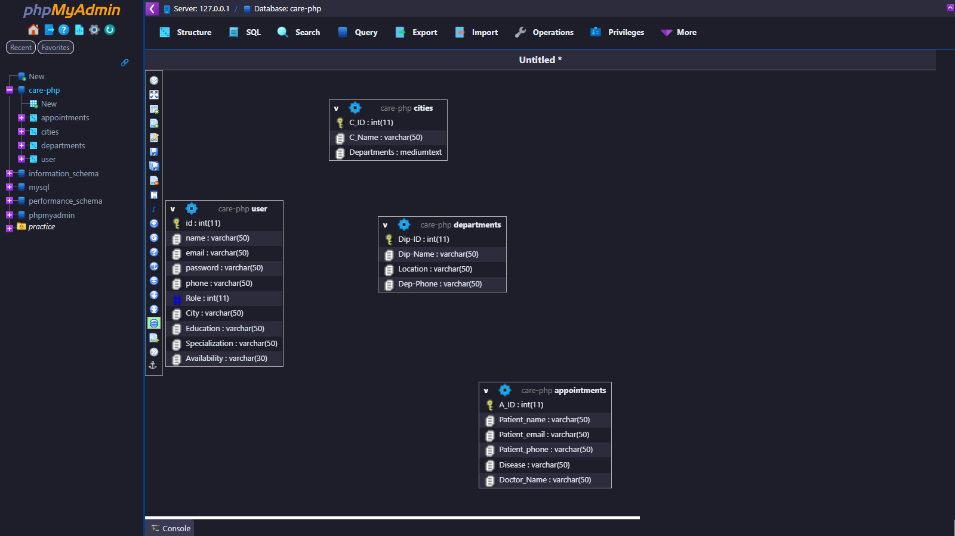

**HOME PAGE:**

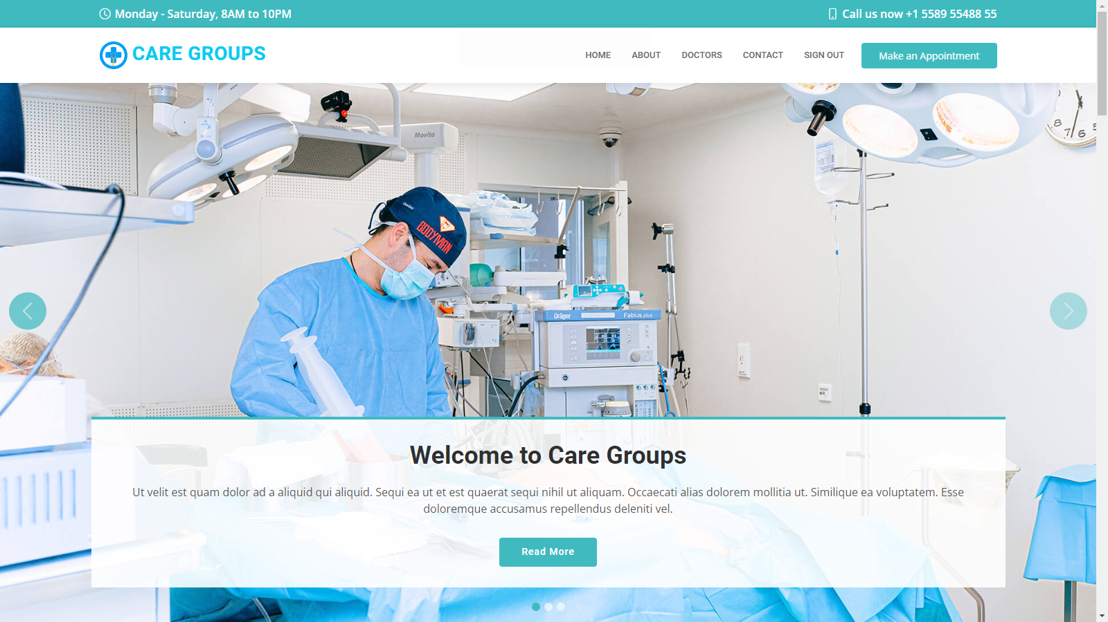

# **Admin Dashboard**

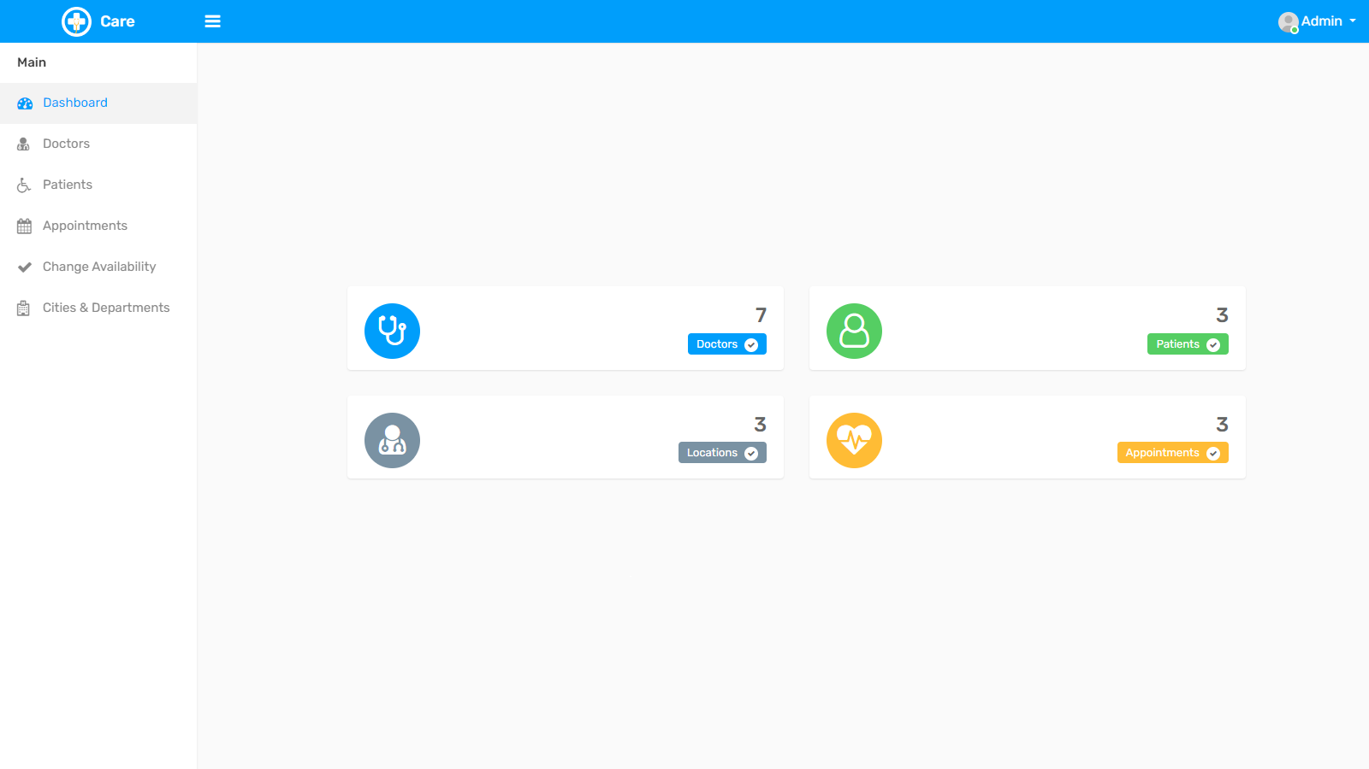

# **Developer Guide**

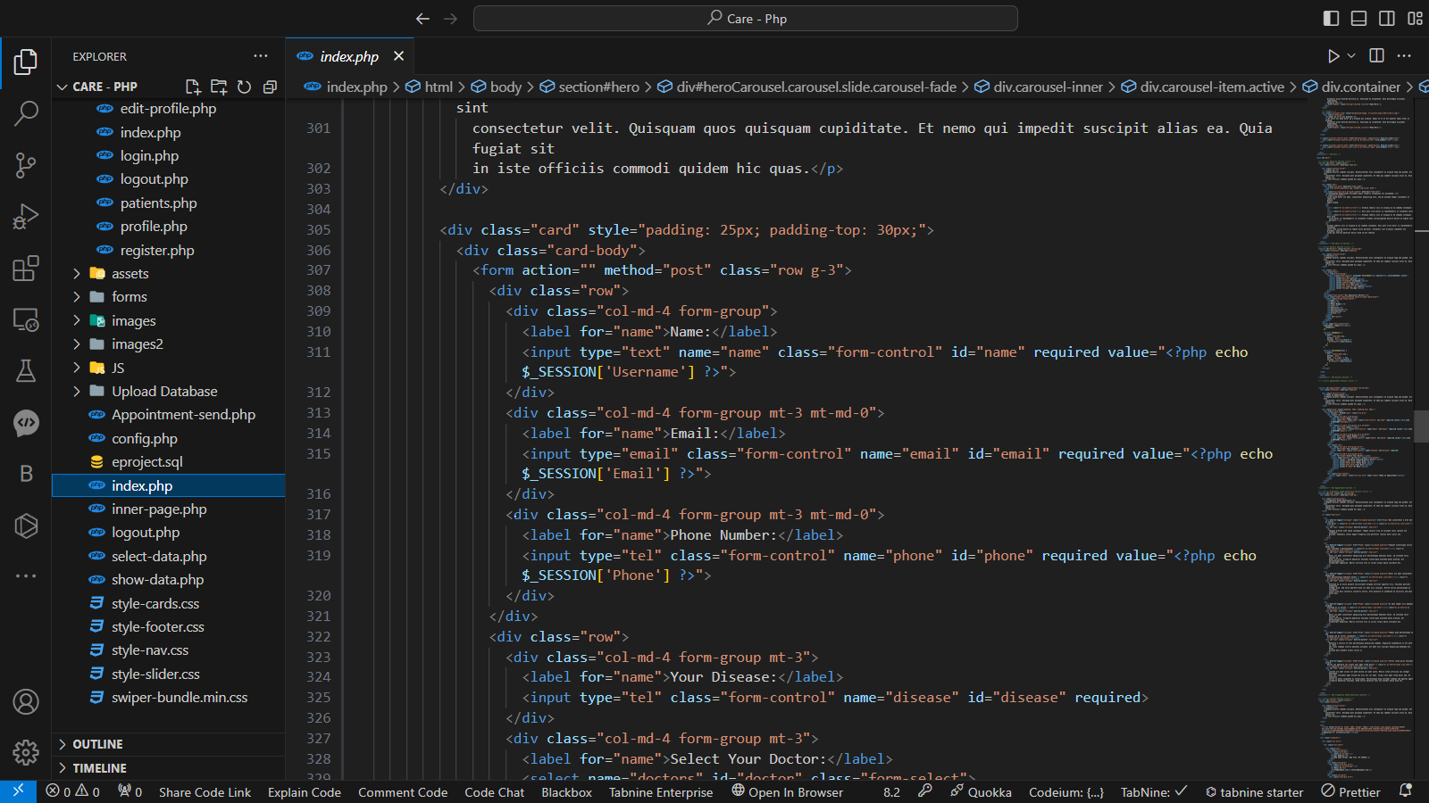

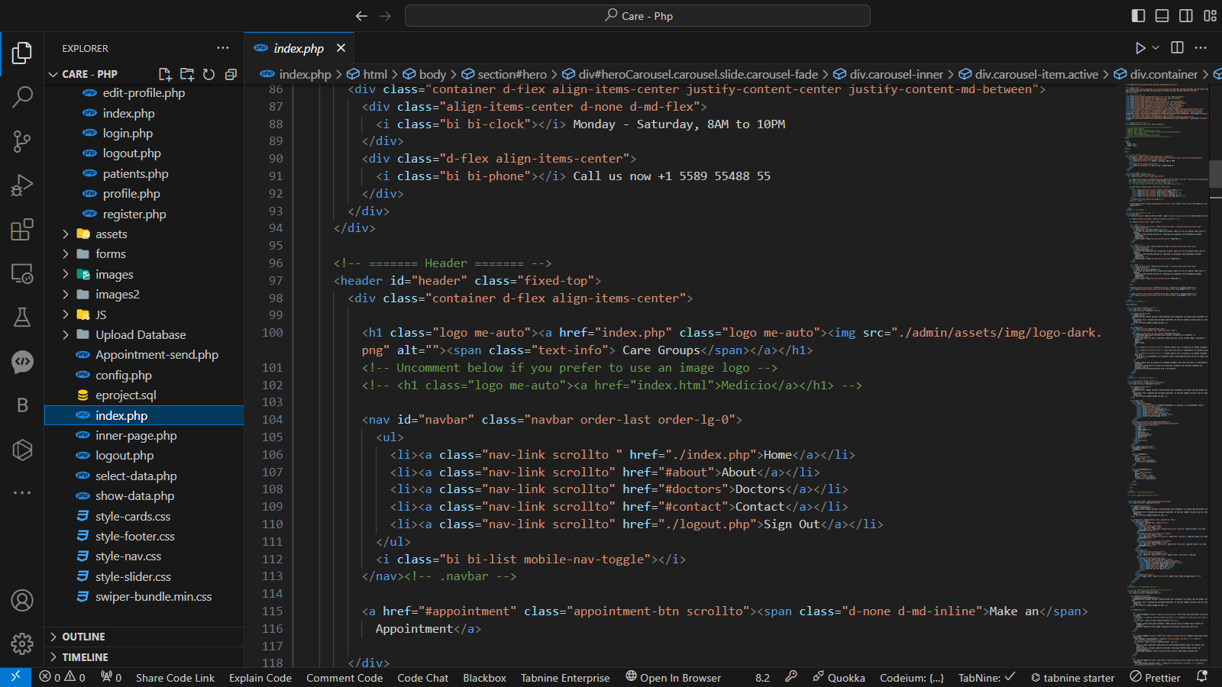

# **Developer Guide (Admin Panel)**

Admin Index

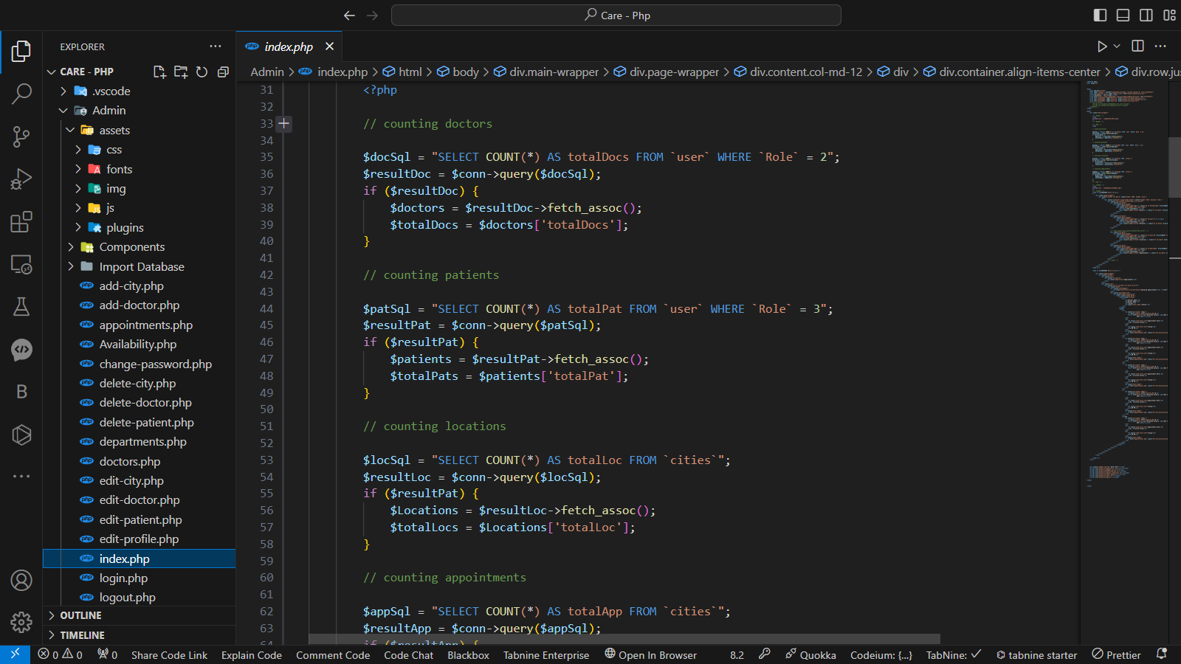

# **Flow Chart:**

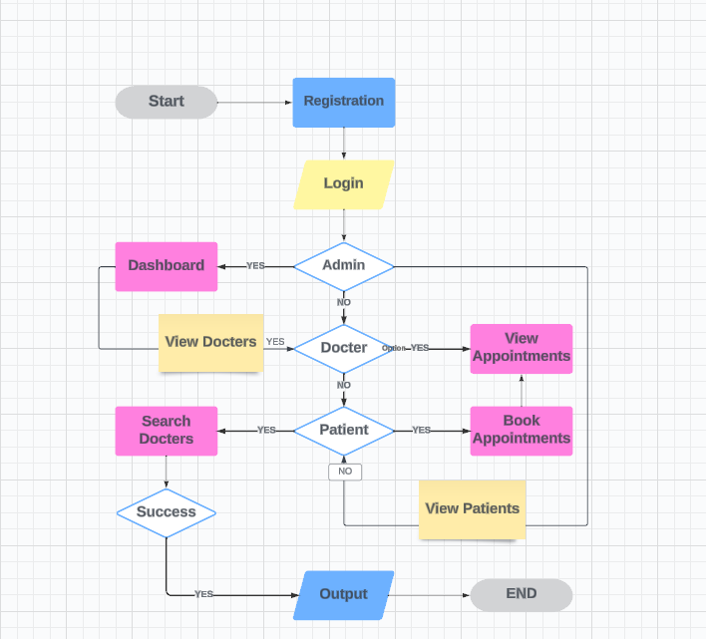

|  |  |  |  |  |
| --- | --- | --- | --- | --- |
| Project Ref. No. | | Project Title | Date of Preparation of Activity Plan | |
| S.No | Task | Care Groups | Actual Days | Status |
| 1 | Analysis | 4 | OK |
| 2 | Design | 7 | OK |
| 3 | Development | 7 | OK |
| 4 | Testing | 2 | OK |
| 5 | Documentation | 2 | OK |

# **Task Sheet**